**Meeting Minutes (Group)**

**Call to order**

A meeting of **Team 07** was held on **New Library Group Study Room 19** on **2020/11/10**. Attendees included Qicheng CHEN, Sihan LU, Longwen HU, Yanbing LUO, Chunlong ZHENG, Zhuopu WANG. No absence.

**Agenda**

Check with each other about **Vue** and **Django**

* Demonstrate Vue and Django using shared screen in Microsoft Team
* Need $npm run build$ to pack vue files for every modification if use with Django
* Need $pip install PyMySQL$ to enable connection from Django to SQL

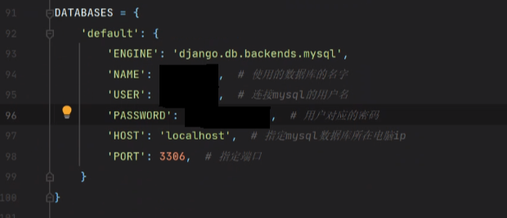

**Unfinished Business**

**New Business**

* **All**: Learn how to bind Vue and Django in one project

**Next Meeting**

2020/11/10, 14:00